In this project for diet plan I am displaying below details
First run cloud application and then click on all buttons and then click on ‘Start Cloud Server’ button and then run User application and upload user.txt file
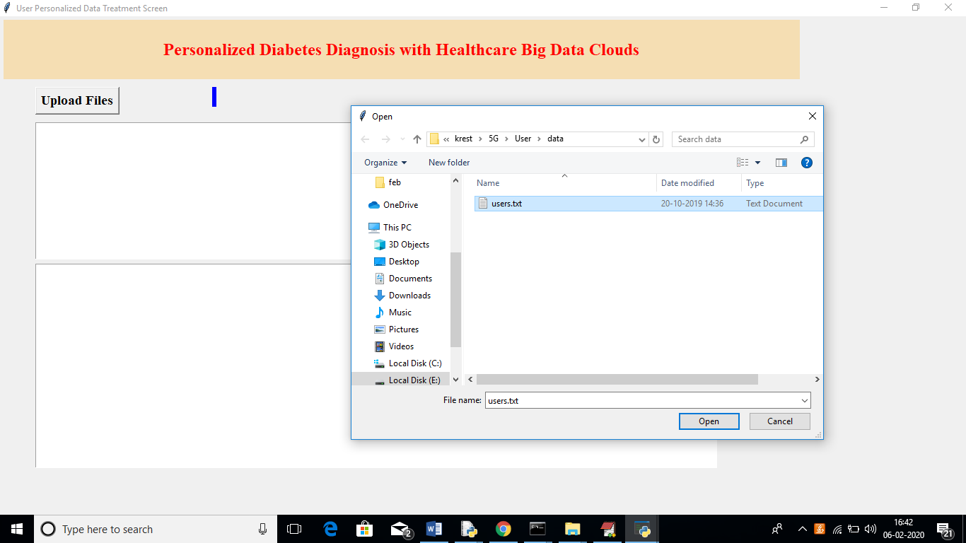
In above screen uploading user file and after upload will get below screen
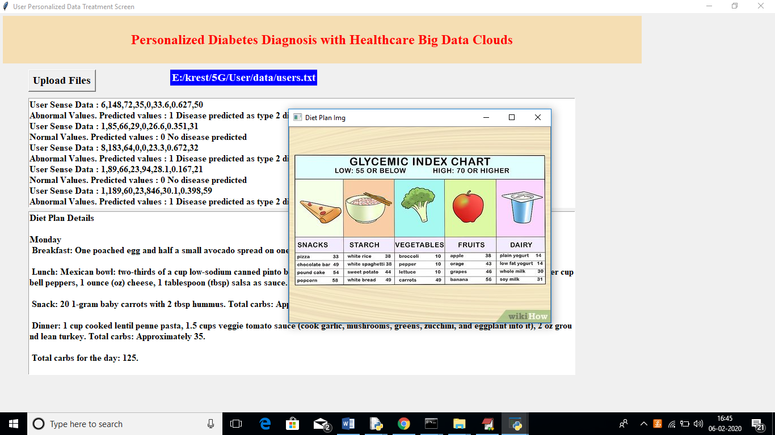
In above screen in first text area application will display disease prediction details and in below text area it will display diet plan with image

